**ENSF-381**: **Full Stack Web Development Laboratory**

**Lab03**

**Section:**

**Group information:**

Kevin He - 30189265

Name 2 (UCID#)

**GitHub Link:**

[**https://github.com/KevinHe854/ensf381_lab03_group21**](https://github.com/KevinHe854/ensf381_lab03_group21)

**Exercise 1 Output:**

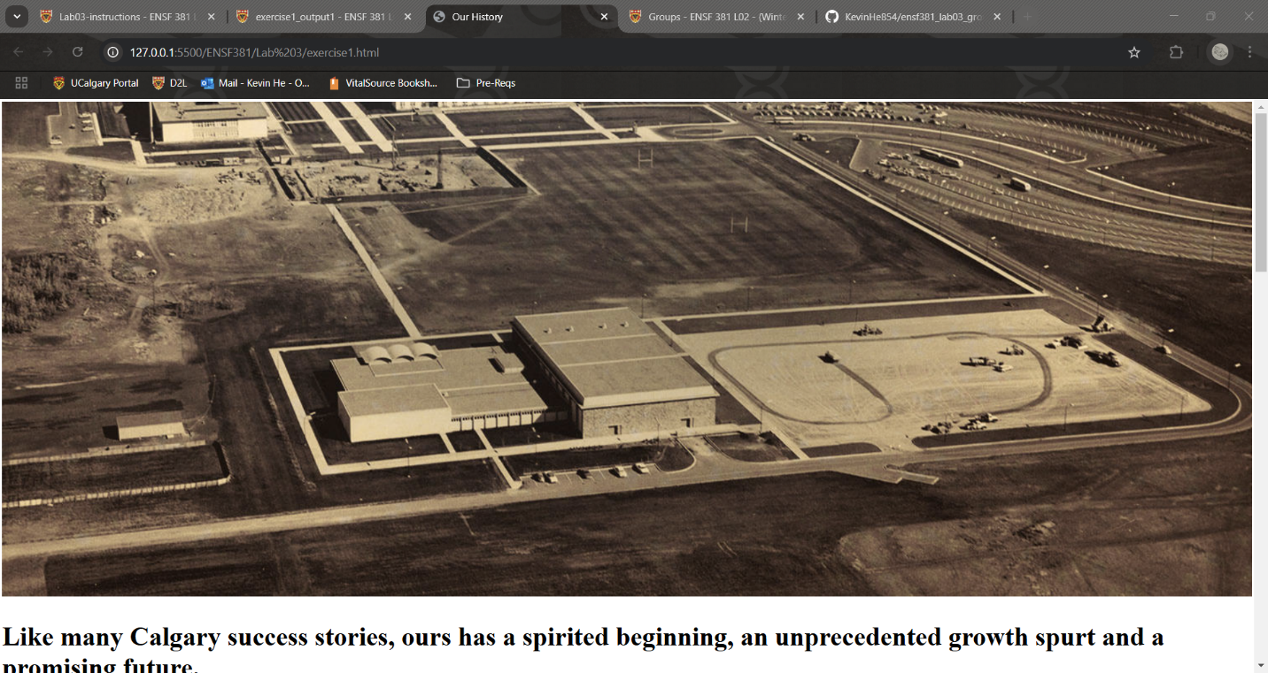

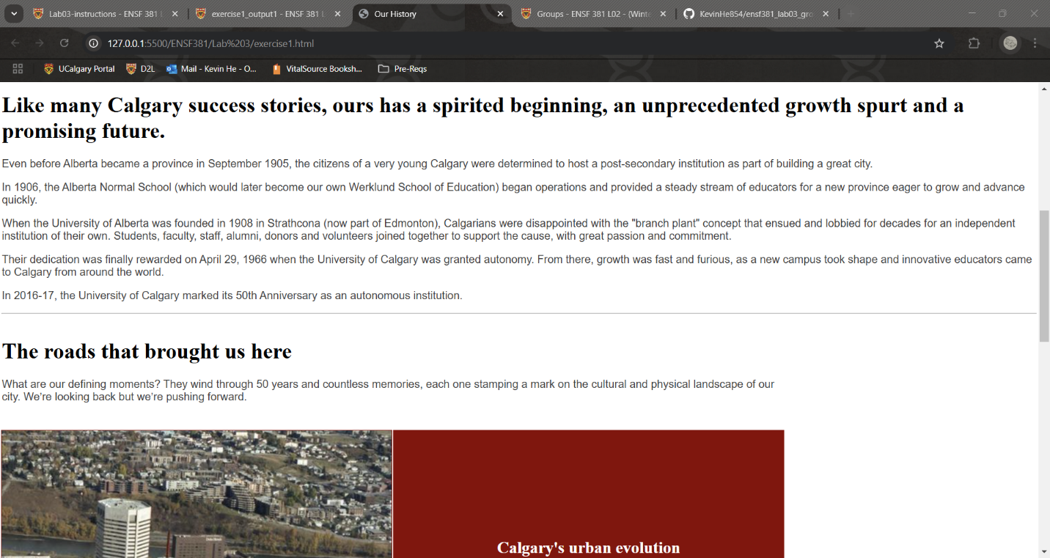

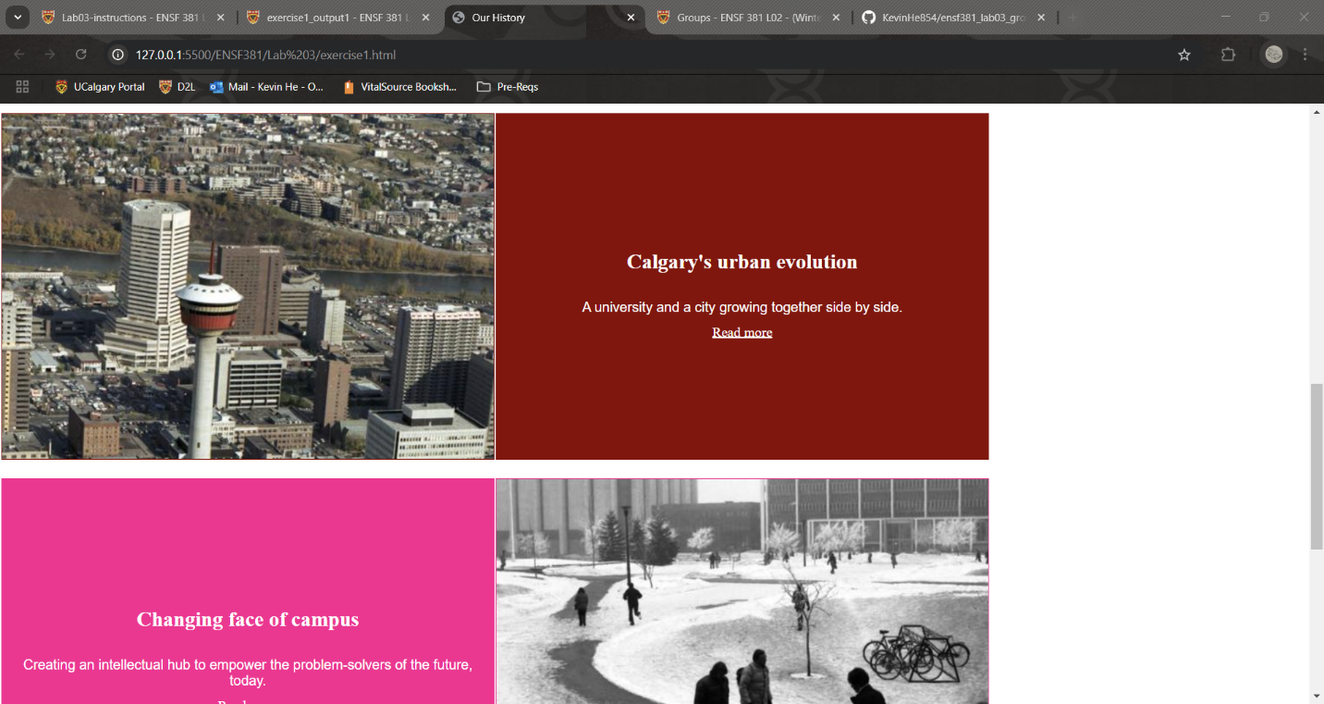

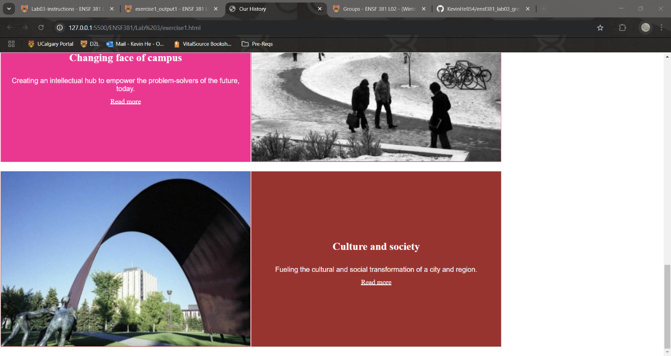

**Exercise 2 Output:**















**Exercise 3 Output:**

